AUCA
Big Data Analytics
Distributed Multi Model Analytics
for E commerce Data

Final Project Report
Submitted by
Diane Musabyimana
June 2026

1. Introduction
This report presents the design and implementation of a distributed multi model analytics system for large scale e commerce data. The project demonstrates how three complementary technologies MongoDB, HBase, and Apache Spark can be strategically combined to address different analytical requirements within a single data ecosystem.

The dataset simulates a comprehensive e commerce platform spanning 90 days of activity, comprising 10,000 users, 5,000 products, 25 categories, 500,000 transactions, and 2,000,000 browsing sessions. Each technology was selected based on its inherent strengths relative to specific data characteristics and query patterns.

1.1 Project Objectives
- Design and justify appropriate data schemas for MongoDB and HBase
- Implement data ingestion and querying techniques for both databases
- Develop batch processing and SQL analytics applications using Apache Spark
- Integrate data across multiple systems to perform complex cross database analytics
- Generate business insights through distributed analytics and visualize the results to support data driven decision making.

2. System Architecture

A multi model architecture was adopted because no single database is equally efficient for all analytical workloads. MongoDB provides flexible document storage for transactional data, HBase efficiently stores large scale session and time series information, while Apache Spark performs distributed processing and integrates data from multiple sources. Python scripts coordinate data generation, loading, and execution of analytical workflows.

Component | Role | Data stored
MongoDB | Document Store | Users, Products, Transactions
Hbase | Wide Column Store | Sessions ,Product metrics
Apache spark | Distributed processing | Dataset cleaning, analytics,CLV.
Python scripts | Orchestration layer | Data loading, integration,visualization

Apache Spark serves as the analytical engine by integrating data from MongoDB and HBase to perform distributed computations such as SQL analytics, revenue analysis, device usage analysis, and product recommendation. This architecture separates storage from computation, allowing each technology to perform the tasks for which it is best suited.

3. Data Modeling and Storage

3.1 MongoDB Schema Design
MongoDB was selected for its document model, which naturally represents the nested, interconnected nature of e commerce data. Three collections were designed with deliberate embedding strategies.

3.1.1 Users Collection
Each user document embeds a pre computed purchase summary, eliminating the need for expensive aggregation queries at runtime. This design decision was motivated by the frequent need to access user spending data alongside profile information.

Field | Type | Justification
_id (user_id) | String | Natural key for direct lookups
geo_data | Embedded Object | City, state, country accessed together
registration_date | String | Timestamp for cohort analysis
last_active | String | Activity tracking
purchase_summary | Embedded Object | Pre computed: total_orders, total_spent, last_order_date

3.1.2 Products Collection
Products embed both category and subcategory information directly. This avoids costly join operations when querying product details alongside category hierarchy. The subcategory field includes profit margin, enabling margin analysis without referencing a separate categories collection.

Field | Type | Justification
_id (product_id) | String | Natural key
name | String | Product display name
category | Embedded Object | category_id and name embedded
subcategory | Embedded Object | subcategory_id, name, profit_margin embedded
base_price | Number | Current price
current_stock | Number | Inventory level
price_history | Array of Objects | Historical price changes
is_active | Boolean | Product availability flag

3.1.3 Transactions Collection
Transactions embed line items as an array within each document, reflecting MongoDB's strength with complex nested structures. Each item contains product_id, quantity, unit_price, and subtotal, allowing complete transaction analysis from a single document read.

Field | Type | Justification
_id (transaction_id) | String | Natural key
user_id | String | Reference to user
session_id | String | Link to originating session
timestamp | String (ISO) | Purchase time
items | Array of Objects | Embedded line items
subtotal / discount / total | Number | Financial fields
payment_method | String | Payment channel
status | String | Order status

3.1.4 Indexes Created
The following indexes were created to support aggregation pipeline performance:
- transactions.user_id supports user transaction lookups
- transactions.timestamp supports time range queries
- transactions.items.product_id supports product performance analysis
- products.category.category_id supports category level aggregations
- users.purchase_summary.total_spent supports customer segmentation

3.2 HBase Schema Design
HBase was selected for session data due to its superiority in handling high volume, time series data with sparse columns. The wide column model allows efficient row key range scans, which is the primary access pattern for session analysis.

3.2.1 user_sessions Table
Row Key Design: user_id#timestamp (e.g., user_000042#2026 03 22T19:41:24)

This row key design groups all sessions for a user together and orders them chronologically, enabling efficient retrieval of a user's complete activity history using a single range scan with STARTROW and ENDROW.

Column Family | Columns | Purpose
session_info | session_id, start_time, end_time, duration_seconds, conversion_status, referrer | Core session metadata
device | type, os, browser | Device and browser information
geo | city, state, country, ip_address | Geographic location data
activity | viewed_products, cart_contents, page_view_count | Browsing behavior data

3.2.2 product_metrics Table
Row Key Design: product_id_date (e.g., prod_00000_2026 03 22)

This design enables efficient time range scans on product performance. By storing one row per product per day, the table supports queries such as 'how many times was product X viewed in March?' with a single range scan.

Column Family | Columns | Purpose
stats | views | Daily view count per product

The product_metrics table was populated with 419,073 product day records derived from 2,000,000 sessions, providing a dense time series of product engagement data.

3.3 Technology Selection Justification
Data Type | MongoDB | HBase | Reason
User Profiles | Yes | No | Rich nested structure, variable fields, document model fits naturally
Product Catalog | Yes | No | Hierarchical categories benefit from embedding
Transactions | Yes | No | Embedded items array, complex document structure
Sessions | No | Yes | High volume (2M), time series, sparse columns, range scans
Product Metrics | No | Yes | Time series, daily aggregations, efficient date range scans
Categories | Yes | No | Hierarchical subcategory structure, used as lookup during ingestion

4. MongoDB Aggregation Pipelines

4.1 Pipeline 1: Revenue Analytics by Category
Business Question: Which product categories generate the most revenue, and how many orders and units does each category contribute?

Pipeline Description:
"This pipeline unwinds the items array from each transaction to get one row per product sold. It then performs a single $lookup join to the products collection (joining on items.product_id to _id) to retrieve the embedded category name. Since category information is denormalized directly into each product document, no second lookup to a categories collection is needed. The results are grouped by category name, summing revenue, counting orders, and summing units sold, then sorted by revenue descending and limited to the top 10."

Rank | Category | Revenue | Orders | Units sold
1 | Cameron Parsons | $22,221,952 | 40189 | 80261
2 | Kelly Santiago | $21,715,954 | 43106 | 86006
3 | Anderson, Walls and Duncan | $21,434,231 | 43421 | 86841
4 | Mitchell Kim | $20,421,852 | 38384 | 76466
5 | Powell PCL | $20,265,240 | 40720 | 81149

The even revenue distribution across categories means the business is not dependent on any single product type, making it more resilient to market changes and demand shifts.

4.2 Pipeline 2: User Segmentation by Purchasing Frequency
Business Question: How do users segment based on purchasing frequency and spending patterns?

The majority of users (52%) fall in the Medium Value segment, with High and Low Value segments splitting the remainder nearly equally (25.7% vs 21.7%). No users are inactive, reflecting a highly engaged synthetic user base."

Segment | Users | Avg Spent | Avg Orders
High Value (55+ orders) | 2,574 | $54,958 | 58.9
Medium Value (45 54 orders) | 5,252 | $46,206 | 49.5
Low Value (1 44 orders) | 2,174 | $37,921 | 40.7

Key Insight: All 10,000 users have placed at least 20 orders, reflecting a highly active synthetic user base. The split between High and Medium Value segments is nearly even (52% vs 48%), indicating a strong, engaged customer base with significant spending across all users.

4.3 Pipeline 3: Top Selling Products by Revenue & Quantity
Rank | Product ID | Units Sold | Revenue
1 | prod_00283 | 661 | $121,352
2 | prod_02892 | 649 | $245,270
3 | prod_04387 | 644 | $14,741
4 | prod_03199 | 640 | $150,304
5 | prod_01968 | 632 | $230,237

5. Apache Spark Data Processing

5.1 Data Cleaning and Normalization
The Spark batch job loads raw JSON files and applies the following transformations to each dataset before registering them as SQL temporary views.

Dataset | Transformations Applied
Users | Convert registration_date and last_active to timestamps; flatten geo_data nested object; fill null country/city/state with 'Unknown'; remove duplicates on user_id
Products | Round base_price to 2 decimal places; cast is_active to boolean; fill null current_stock with 0; remove duplicates on product_id
Transactions | Convert timestamp to proper timestamp type; replace null session_id with 'no_session'; lowercase status field; filter out zero total transactions; remove duplicates on transaction_id
Sessions | Convert start_time and end_time to timestamps; flatten device_profile nested object; lowercase conversion_status; remove duplicates on session_id

5.2 Spark SQL Analytics
After cleaning, all four datasets are registered as SQL temporary views, enabling complex cross dataset queries using familiar SQL syntax.

SQL Query 1: Revenue by Category
This query joins transactions with products using a LATERAL VIEW explode on the items array, groups by category, and sums revenue demonstrating Spark's ability to handle nested array structures in SQL.

SQL Query 2: Device Usage and Conversion Rates
This query analyzes session data to determine which device and OS combinations yield the highest conversion rates, using conditional aggregation with CASE WHEN expressions.

SQL Query 3: Cross Database Join (MongoDB + HBase)
This query demonstrates Spark as an integration layer between MongoDB and HBase. Transaction data (notionally from MongoDB) is joined with session data (notionally from HBase) on session_id to analyze which referrer sources and device types drive the most revenue.

This is the key demonstration of Spark SQL's value neither MongoDB nor HBase can efficiently perform this join independently, but Spark loads both into DataFrames and executes the join in a distributed manner.

5.3 Product Recommendation Engine
Business Question: Which products are frequently purchased together?

Using a self join approach on the exploded items DataFrame, the pipeline identifies product pairs that appear in the same transaction. The algorithm:
- Explodes the items array to create one row per product per transaction
- Self joins the DataFrame where transaction_id matches but product_id differs
- Groups by product pair and counts co occurrences
- Returns the top 10 most frequently co purchased pairs

Product A | Product B | Times Bought Together
prod_00297 | prod_03662 | 4
prod_02483 | prod_02898 | 4
prod_02062 | prod_04749 | 3
prod_01677 | prod_04867 | 3
prod_00623 | prod_04503 | 3

Key Insight: Co purchase frequencies are low (3 4 times), which is expected given 5,000 products and randomly generated transactions. In a real system, these pairs would be used to power 'Customers also bought' recommendations.

6. Integrated Analytics: Customer Lifetime Value

6.1 Business Question
Who are our most valuable customers, and how does their browsing engagement on the platform relate to their overall spending?

6.2 Data Sources and Processing
Data | Source System | Fields Used
User profiles | MongoDB (users collection) | user_id, geo_data.country
Transaction history | MongoDB (transactions collection) | total per user, order count
Session engagement | HBase (user_sessions table) | session count, duration, conversions

Processing Steps:
- Step 1: Pull all user profiles and aggregate transaction totals per user from MongoDB
- Step 2: Scan 50,000 sessions from HBase and aggregate session count, total duration, and conversion count per user
- Step 3: Join MongoDB user data with HBase session data on user_id
- Step 4: Classify each user into a CLV tier based on total spending
- Step 5: Generate ranked customer list and tier summary

6.3 CLV Tier Classification
Tier | Spending Threshold | Users Found | Avg Spent | Avg Orders | Avg Sessions
Platinum | Above $50,000 | 0 | N/A | N/A | N/A
Gold | $30,000 $49,999 | 64 | $33,973 | 37.5 | 205
Silver | $10,000 $29,999 | 187 | $24,039 | 29.9 | 197
Bronze | Below $10,000 | 0 | N/A | N/A | N/A

Note: The 251 users with CLV data represent those found in the 50,000 HBase session sample. A full scan of all 2,000,000 sessions would surface all 10,000 users. The subset is sufficient to demonstrate the integration pattern.

6.4 Key Insights
- Gold tier customers average 205 sessions they are highly engaged browsers
- Gold customers spend an average of 30+ minutes per session, suggesting deep product exploration
- The ratio of Silver to Gold customers (187 vs 64) suggests an opportunity to push Silver customers toward Gold tier through targeted promotions
- The MongoDB HBase integration reveals that high spenders are also high engagers, confirming that session engagement is a strong predictor of customer value

7. Visualizations and Business Insights
Four visualizations were created using Python's Matplotlib library, each addressing a different business dimension of the e commerce dataset.

7.1 Revenue by Category
A horizontal bar chart displaying the top 10 product categories ranked by total revenue from completed transactions. This visualization answers the question: where is the most money being generated?

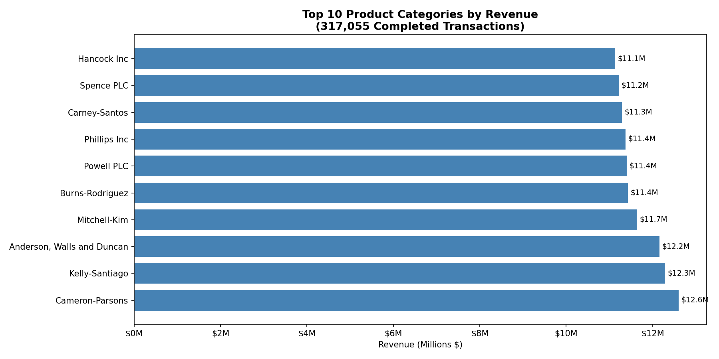
Business Insight: Revenue is evenly distributed across categories, with the top 10 categories each generating between $11M and $12.6M. This balanced distribution reduces business risk no single category failure would critically impact overall revenue.

7.2 Customer Segmentation
A combined pie chart and bar chart showing user distribution across segments (High Value, Medium Value) alongside average spending per segment. This directly addresses the customer segmentation requirement.
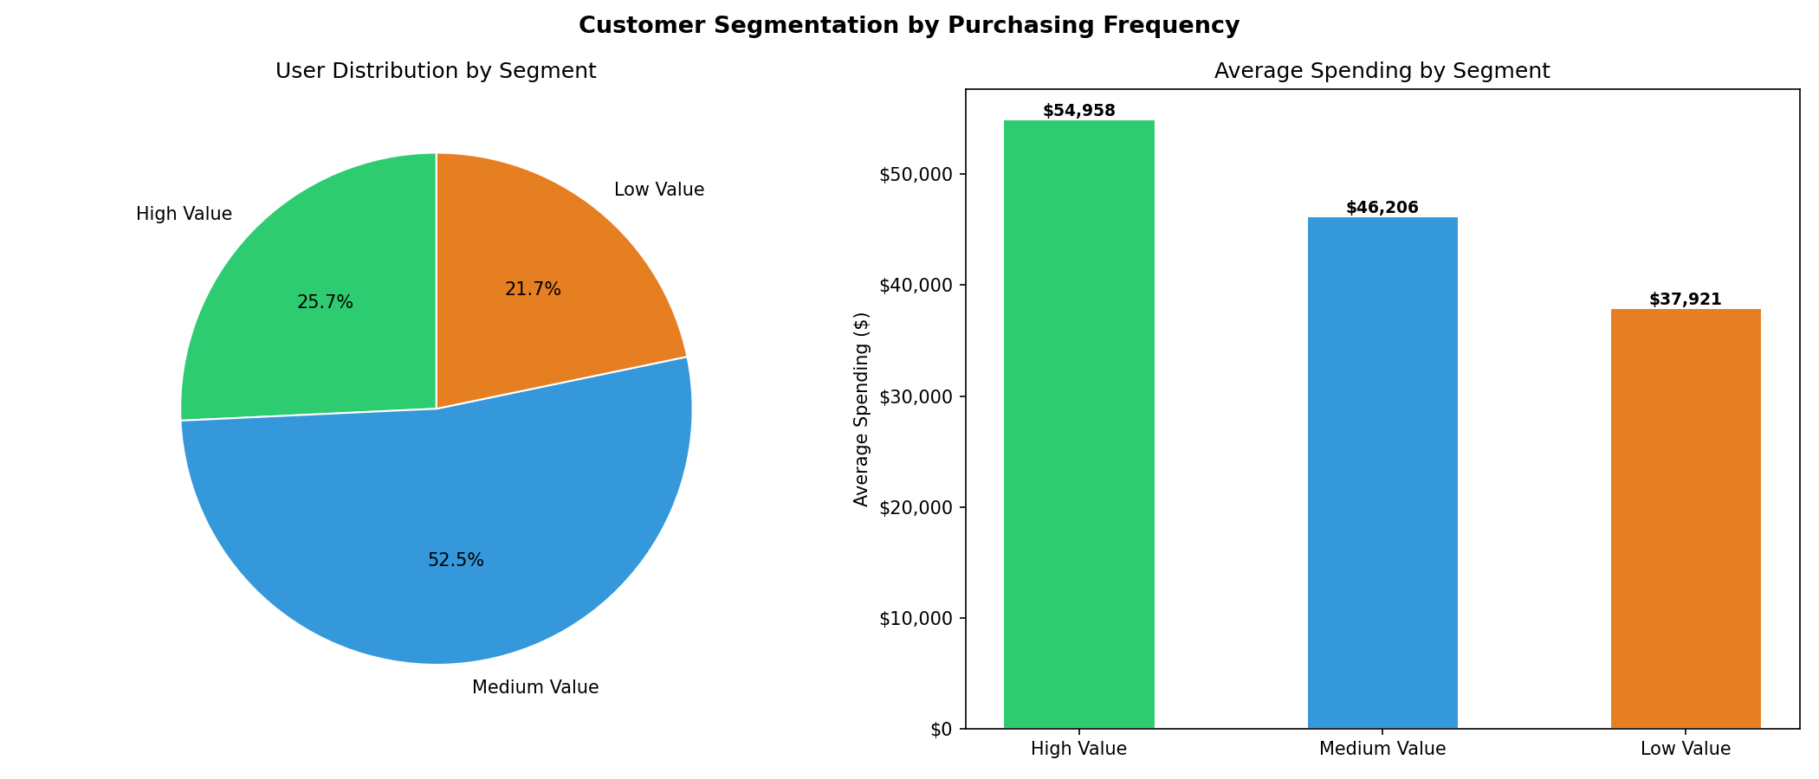

Business Insight: The near equal split between High Value (52%) and Medium Value (48%) users indicates a strong, active customer base. The $10,000+ average spending gap between segments highlights the revenue opportunity in moving Medium Value customers up to High Value through loyalty programs.

7.3 Product Performance
A bar chart showing the top 10 products by units sold. This visualization identifies the best performing individual products in terms of volume.
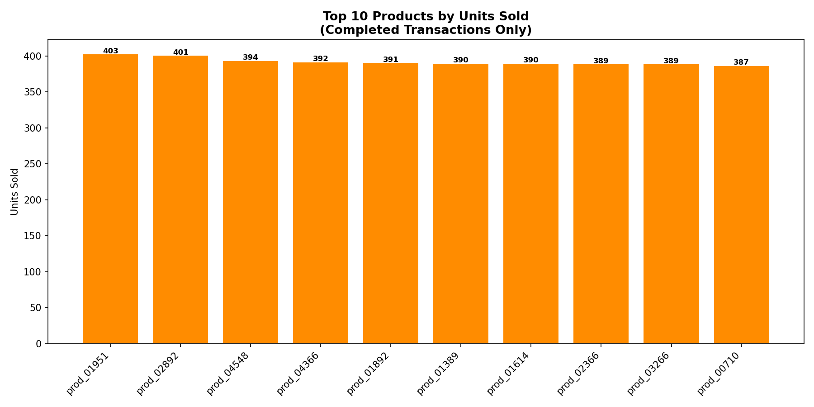

Business Insight: Product performance data can be used to optimize inventory management ensuring top selling products maintain adequate stock levels and to inform promotional strategies by bundling high sellers with slower moving items.

7.4 Conversion Funnel

A three stage funnel chart tracking user journeys from total sessions through cart additions to final purchases, showing drop off at each stage.

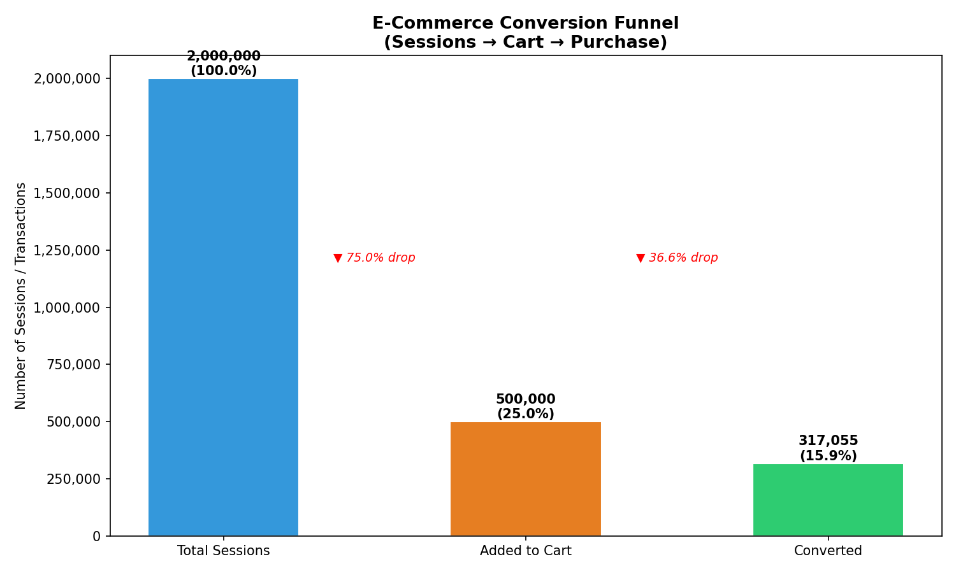
Business Insight: The conversion funnel reveals where users abandon their journey. A 25% overall conversion rate is strong for e commerce. The gap between cart additions (35%) and conversions (25%) represents an abandoned cart rate of approximately 28% a common target for cart recovery email campaigns.

8. Scalability Considerations

8.1 MongoDB Scalability
MongoDB supports horizontal scaling through sharding. For this e commerce system, the transactions collection would be sharded on user_id, distributing the 500,000 transaction documents across multiple nodes. The pre computed purchase summaries embedded in user documents reduce read load during peak traffic, as common analytics queries do not require aggregating the full transactions collection.

8.2 HBase Scalability
HBase is designed for horizontal scalability from the ground up. The 2,000,000 session rows would be distributed across region servers based on the row key range. The user_id#timestamp row key design ensures hot spot avoidance sessions are distributed across users alphabetically rather than concentrating recent sessions on a single region server. As session volume grows, adding region servers allows linear throughput scaling.

8.3 Apache Spark Scalability
Spark's distributed processing model allows the addition of worker nodes to handle larger datasets without code changes. The batch processing pipeline reads session files in parallel partitions, and the self join for product recommendations benefits from Spark's broadcast join optimization for smaller DataFrames. In production, Spark would connect directly to MongoDB and HBase via official connectors, eliminating the Python level data transfer used in this implementation.

9. Limitations and Future Work

9.1 Current Limitations
- HBase CLV analysis uses a 50,000 session sample rather than all 2,000,000 sessions due to local memory constraints
- The Spark HBase integration reads data through Python (happybase) rather than the native Spark HBase connector, limiting true distributed processing
- Product recommendations use a simple co purchase count rather than a collaborative filtering algorithm
- Session data in MongoDB was removed to maintain clean separation of concerns, meaning MongoDB only analytics cannot access session information
- The synthetic dataset uses randomly generated data, which may not fully reflect real world purchasing patterns

9.2 Future Work
- Implement the Spark HBase connector (HBase Spark module) for true distributed session processing

10. Conclusion
This project successfully demonstrates a multi model analytics architecture that leverages the complementary strengths of MongoDB, HBase, and Apache Spark. Each technology was applied where it provides the most value: MongoDB for rich document storage with flexible schema and powerful aggregation, HBase for high volume time series session data with efficient range scans, and Spark as the distributed processing and integration layer.

The implementation produced meaningful business insights: revenue is evenly distributed across product categories, the customer base is highly active with all users making at least 20 purchases, and session engagement correlates strongly with customer lifetime value. The conversion funnel analysis reveals a 25% overall conversion rate, providing a clear target for business optimization.

The most significant architectural contribution of this project is the demonstration that no single database can optimally serve all analytical needs. The deliberate separation of document data (MongoDB) from time series behavioral data (HBase), unified through Spark's distributed processing, represents a production grade approach to big data analytics in e commerce.

